Appendix A9 from Online Safety Policy Templates
4

A9 Responding to incidents of misuse – flow chart
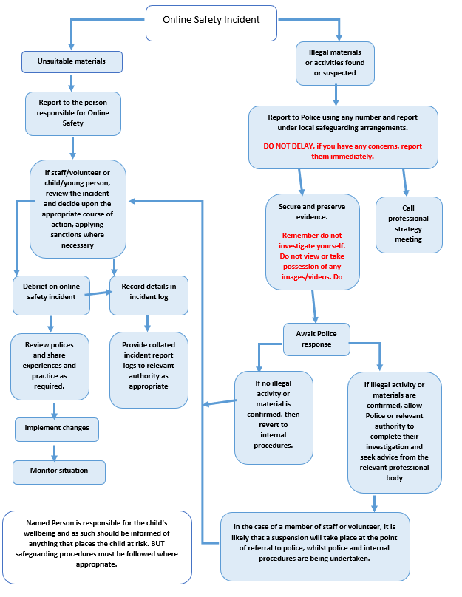

Copyright of these policy templates is held by SWGfL. Schools/colleges and other educational institutions are permitted free use of the policy templates for the purposes of policy review and development. Any person or organisation wishing to use the document for other purposes should seek consent from SWGfL (onlinesafety@swgfl.org.uk) and acknowledge its use.
Every effort has been made to ensure that the information included in this document is accurate, as at the date of publication in September 2022. However, SWGfL cannot guarantee its accuracy, nor can it accept liability in respect of the use of the material.
© SWGfL 2022

